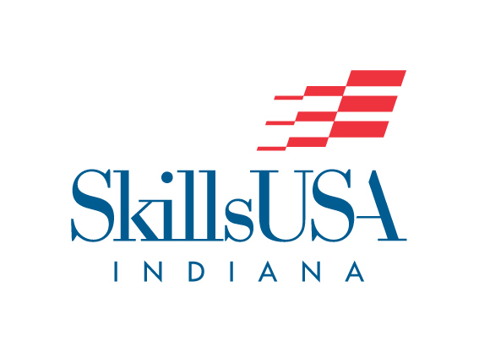
2022 State Leadership and Skills Conference
Cancellation and Refund Request Form

SkillsUSA Indiana Refund Procedure:

- All requests for refunds must be submitted on this form. No refunds will be processed after this date, March 11, 2022. (Full refund- 3/5/22 by 4 pm EST; 50% refund- 3/6-11/22; 0% refund after 3/11/22)
- All eligible refunds will be processed after the conference for which they are requested.
- This form must be received by the date set for each conference to receive the maximum refund available.

Date of Request_____________________________________________________________
Conference for which the refund is being requested ________________________________________
School ____________________________________ Advisor _____________________________
School Address __________________________________________________
City, State, Zip _ ______________________________________________________
Name of Attendee(s) to Cancel and reason for cancellation:
_________________________________________ ______________________________________
_________________________________________ ______________________________________
_________________________________________ ______________________________________
Duplicate this form as necessary.
Total number of Cancellations: __________ - $ ___________ = $ ___________
Refund Method:  Refund by check

Mail to: SkillsUSA Indiana email to: Kelley Baker
PO Box 34689 kelley.skillsusa@gmail.com
Indianapolis, IN 46234
317-667-8247

For Office Use Only
Date Received: _______________ Approved By: _______________ Date: _______________ Account #: ______________

